**San Francisco General Hospital: Connectivity through Electronic Referral**

[San Francisco General Hospital & Trauma Center](https://zuckerbergsanfranciscogeneral.org/) (SFGH) is the city’s only public hospital and Level 1 Trauma Center for the residents of San Francisco and northern San Mateo counties. The hospital is owned and operated by the City and County of San Francisco’s Department of Public Health and serves as the hub of the county’s safety net delivery system, which includes 35 community health centers, clinics and affiliated partners. The hospital serves as a teaching hospital for the University of California, San Francisco, and this entire system benefits from shared access to patients’ SFGH electronic medical records.

Until recently, the system was plagued with a severe backlog for medical sub-specialty appointments. For example, the wait time for a gastroenterology appointment was 11 months. Referrals were paper-based and faxed or hand-delivered; sometimes the referral was never received, and the patient never scheduled. If a patient needed an expedited appointment, the primary care provider had to spend time trying to contact a specialist to advocate on the patient’s behalf.

In order to address the backlog, Dr. Hal Yee, chief of the Gastroenterology and Hepatology Division, developed an electronic referral management and consultation system (eReferral). The two primary goals of the system were to:

1. Track referrals so that there was accountability for referrals.

2. Reduce wait times.

The technology platform was developed by the hospital’s Information Systems Department and improved with the support of grant funds that also initially paid for the specialist’s time to review the incoming queue of referrals.

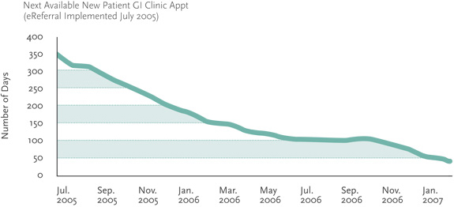

Dr. Alice Chen is the medical director for San Francisco General’s Adult Medical Center, and together with Dr. Yee, successfully spread the eReferral system to more than 30 medical specialty clinics and services at SFGH, including radiology services, home care and diabetes support groups. The system’s key components include the following:

* There is a centralized, electronic queue for each participating specialty service.
* All referring clinics must use the eReferral system to refer to participating specialty services.
* Each participating specialty service has a designated specialist clinician reviewer with dedicated time to review and respond to referral requests. The reviewer can use the system to schedule appointments, triage patients, request clarification of the consultative question and provide guidance for pre-visit evaluation.
* The referring provider and specialist reviewer can communicate in an iterative fashion using the eReferral system until the patient’s clinical issue has been addressed, with or without an appointment.
* The eReferral system is tightly integrated with the hospital EMR so that all information exchange is documented in the patient’s chart in real time.
* The system is limited to initial referrals (rather than referral for follow-up care) because these were decided to be the best use of the reviewer’s time.

The following flow diagram depicts how the eReferral system works.

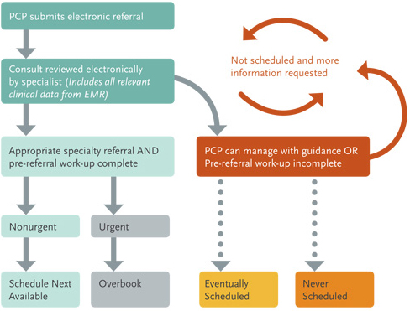

Drs. Yee and Chen believe that one of the primary values of the eReferral system is facilitation of communication between primary care and specialist providers. It is important to note that implementation of these consultations may be difficult because of legal, medical and logistical reasons. Nonetheless, primary care providers now receive guidance on evaluation and management in a timely fashion, while specialists who see patients in clinic receive clear consultative questions. This information connectivity not only reduces unnecessary specialist appointments but gives PCPs more opportunity to learn and treat their own patients’ clinical issues.

Local PCPs are satisfied with the eReferral system, especially clinics with good Internet access. Clinics that only have intermittent internet access are less able to fully benefit from the system. In these practices, referrals tend to be entered by clerical staff yielding a less informative clinical referral and less opportunity for back-and-forth communication between providers.

Their eReferral system recently [received accolades](http://www.innovations.ahrq.gov/content.aspx?id=2759)and is promoted as a successful system. The following results demonstrate that the system’s goal of reducing wait times has been achieved. It is clear that SFGH’s eReferral system has achieved its goals of improving specialty access and reducing specialty visits.