**Genesys Health System**

**Genesys Health System: Developing Linkages with Community Resources**

Genesys Health System, a member of Ascension Health, is a regionally integrated health care delivery system providing a full continuum of care. It partners with approximately 140 primary care physicians in central Michigan. [Genesys HealthWorks](http://www.genesyshealthworks.org/" \t "_blank" \o "Genesys HealthWorks)is a strategic initiative within Genesys Health System to create a new model of care that is focused on health, not just disease. The program focuses on coordinating care for patients utilizing community resources. The initiative is led by Dr. Trissa Torres who is a physician focusing on preventive medicine and public health.

HealthWorks employs Health Navigators -- members of the primary care practice team who support patients and the work of the practice and develop these community service relationships. The Health Navigator’s primary focus is to support patients in self-care, particularly health behavior changes such as eating healthier, increasing physical activity or quitting smoking. As patients identify barriers to engaging in their own self-care and adopting healthy behaviors, Health Navigators often suggest community resources to enhance support for patient self-management. Their effort to develop partnerships with community resources is analogous to efforts to identify and develop relationships with key medical specialists.

HealthWorks Health Navigators emphasize the distinction between simply making a referral and making an effective referral that results in access to services. “Behavior change takes place in the context of a relationship,” explains Dr. Torres. A community referral is most effective when, as Dr. Torres describes you “transfer the relationship between the Health Navigator and the patient to the community resource.” The Health Navigator is knowledgeable about key community resources and knows how to prepare the patient for the referral. For example, the Health Navigator can share details with the patient about what their initial experience will be, such as whether the patients should bring a towel and a change of clothes to the swim class or telling the patient that they’ll meet with "Lynda", who is very friendly. Effective referrals go above and beyond handing the patient a brochure or referral slip. By sharing specific details about what the patient should expect and who to go to for help, the patient is more likely to follow through on the referral. In 2009, Health Navigators made the following types of linkages:

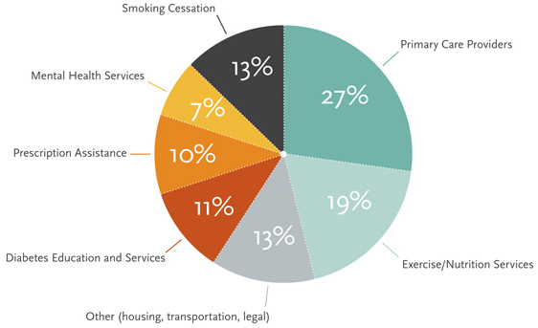

Health Navigators follow-up with patients after the referral visit. They inform the patient that they will contact them after the scheduled referral. During this follow-up contact, the Health Navigator identifies and addresses problems. If the patient did not complete the referral, the Health Navigator works with the patient to identify and overcome the barriers to accessing the community resource.

The Genesys HealthWorks Health Navigator program conducted a telephone survey with almost 2,000 patients to evaluate their program. Patients were interviewed at initiation and six months after they began the program. The following self-reported improvements in health behaviors and health outcomes were found:

* 17% (120/713) of smokers quit smoking
* 45% (217/481) who had never received formal diabetes education attended Diabetes Self Management Education
* 42% (260/620) of patients screening positive for depression reported improved symptoms

In addition, the interviews found high patient satisfaction with the program. Many patients expressed appreciation for the additional support they received. Dr. Torres and her team are dedicated to improving the health of the patients by building relationships and making effective referrals to community organizations.