The Framework for Creating Regional Healthcare Improvement
Ed Wagner, Brian Austin, and Katie Coleman, MacColl Center for Healthcare Innovation

A growing number of markets in the United States are exploring broad-based, geographically focused improvements to the community’s health care quality and costs. The MacColl Center has been examining these coalitions and the literature to see what lessons can be drawn about how they are formed and the work they do. The proposed Framework and its specific components are not evidence-based, as rigorous research evaluating the impacts of regional initiatives and the proposed components on regional quality, health outcomes, and costs has been very limited. Therefore, the Framework is descriptive, a compendium of important local responses to the major problems and trends in current American healthcare, but nonetheless helpful, we hope, at spurring discussion and organizing thinking on what elements, in what combinations, have the greatest chance of success.

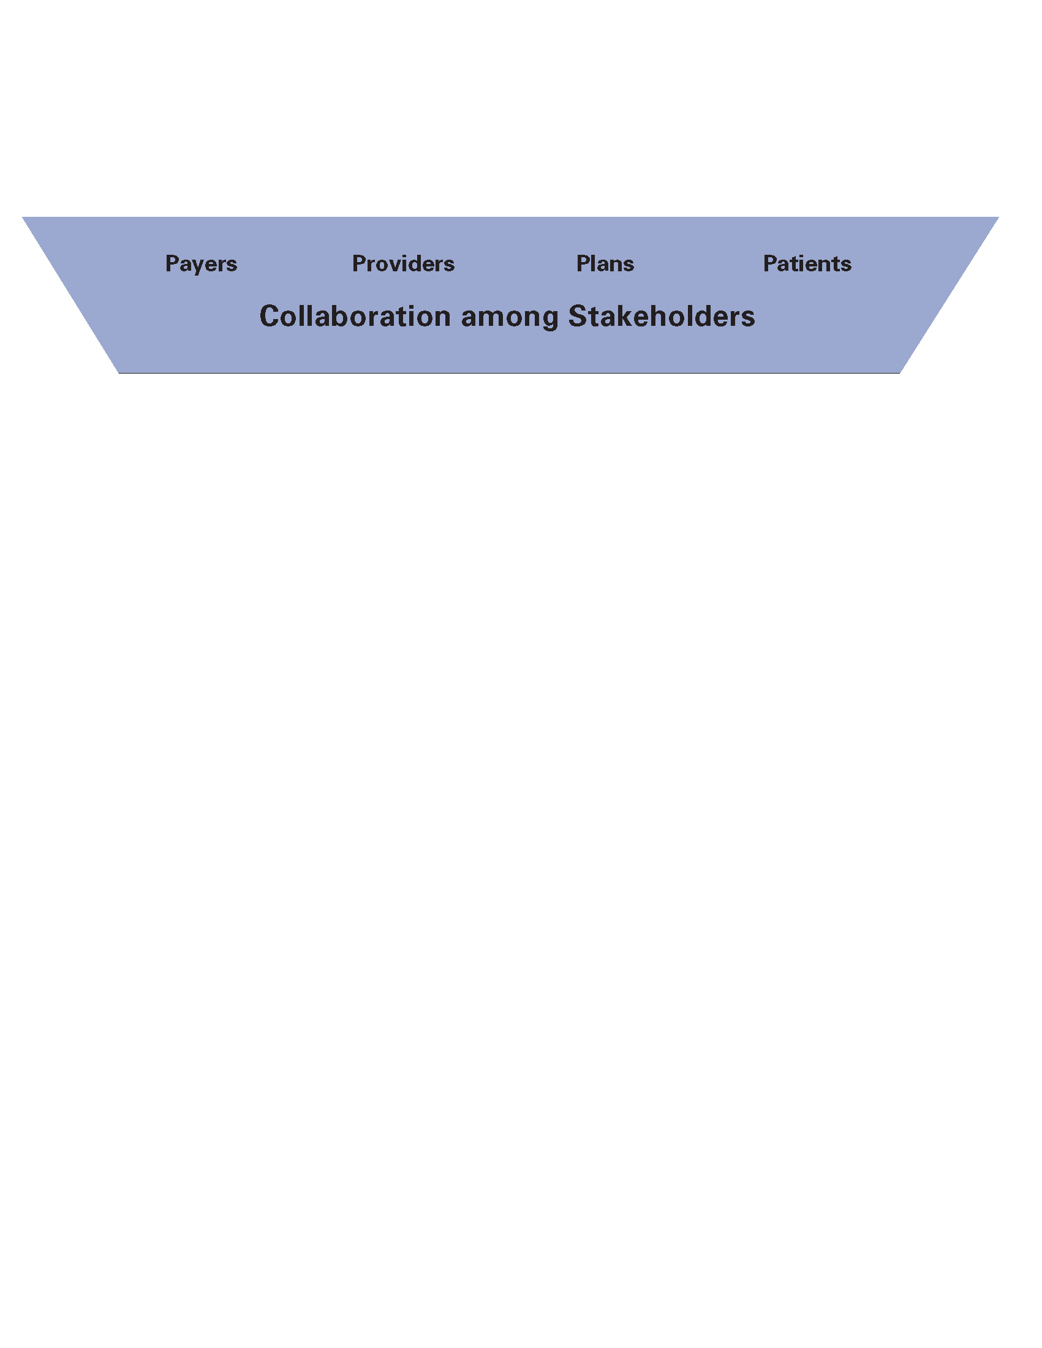


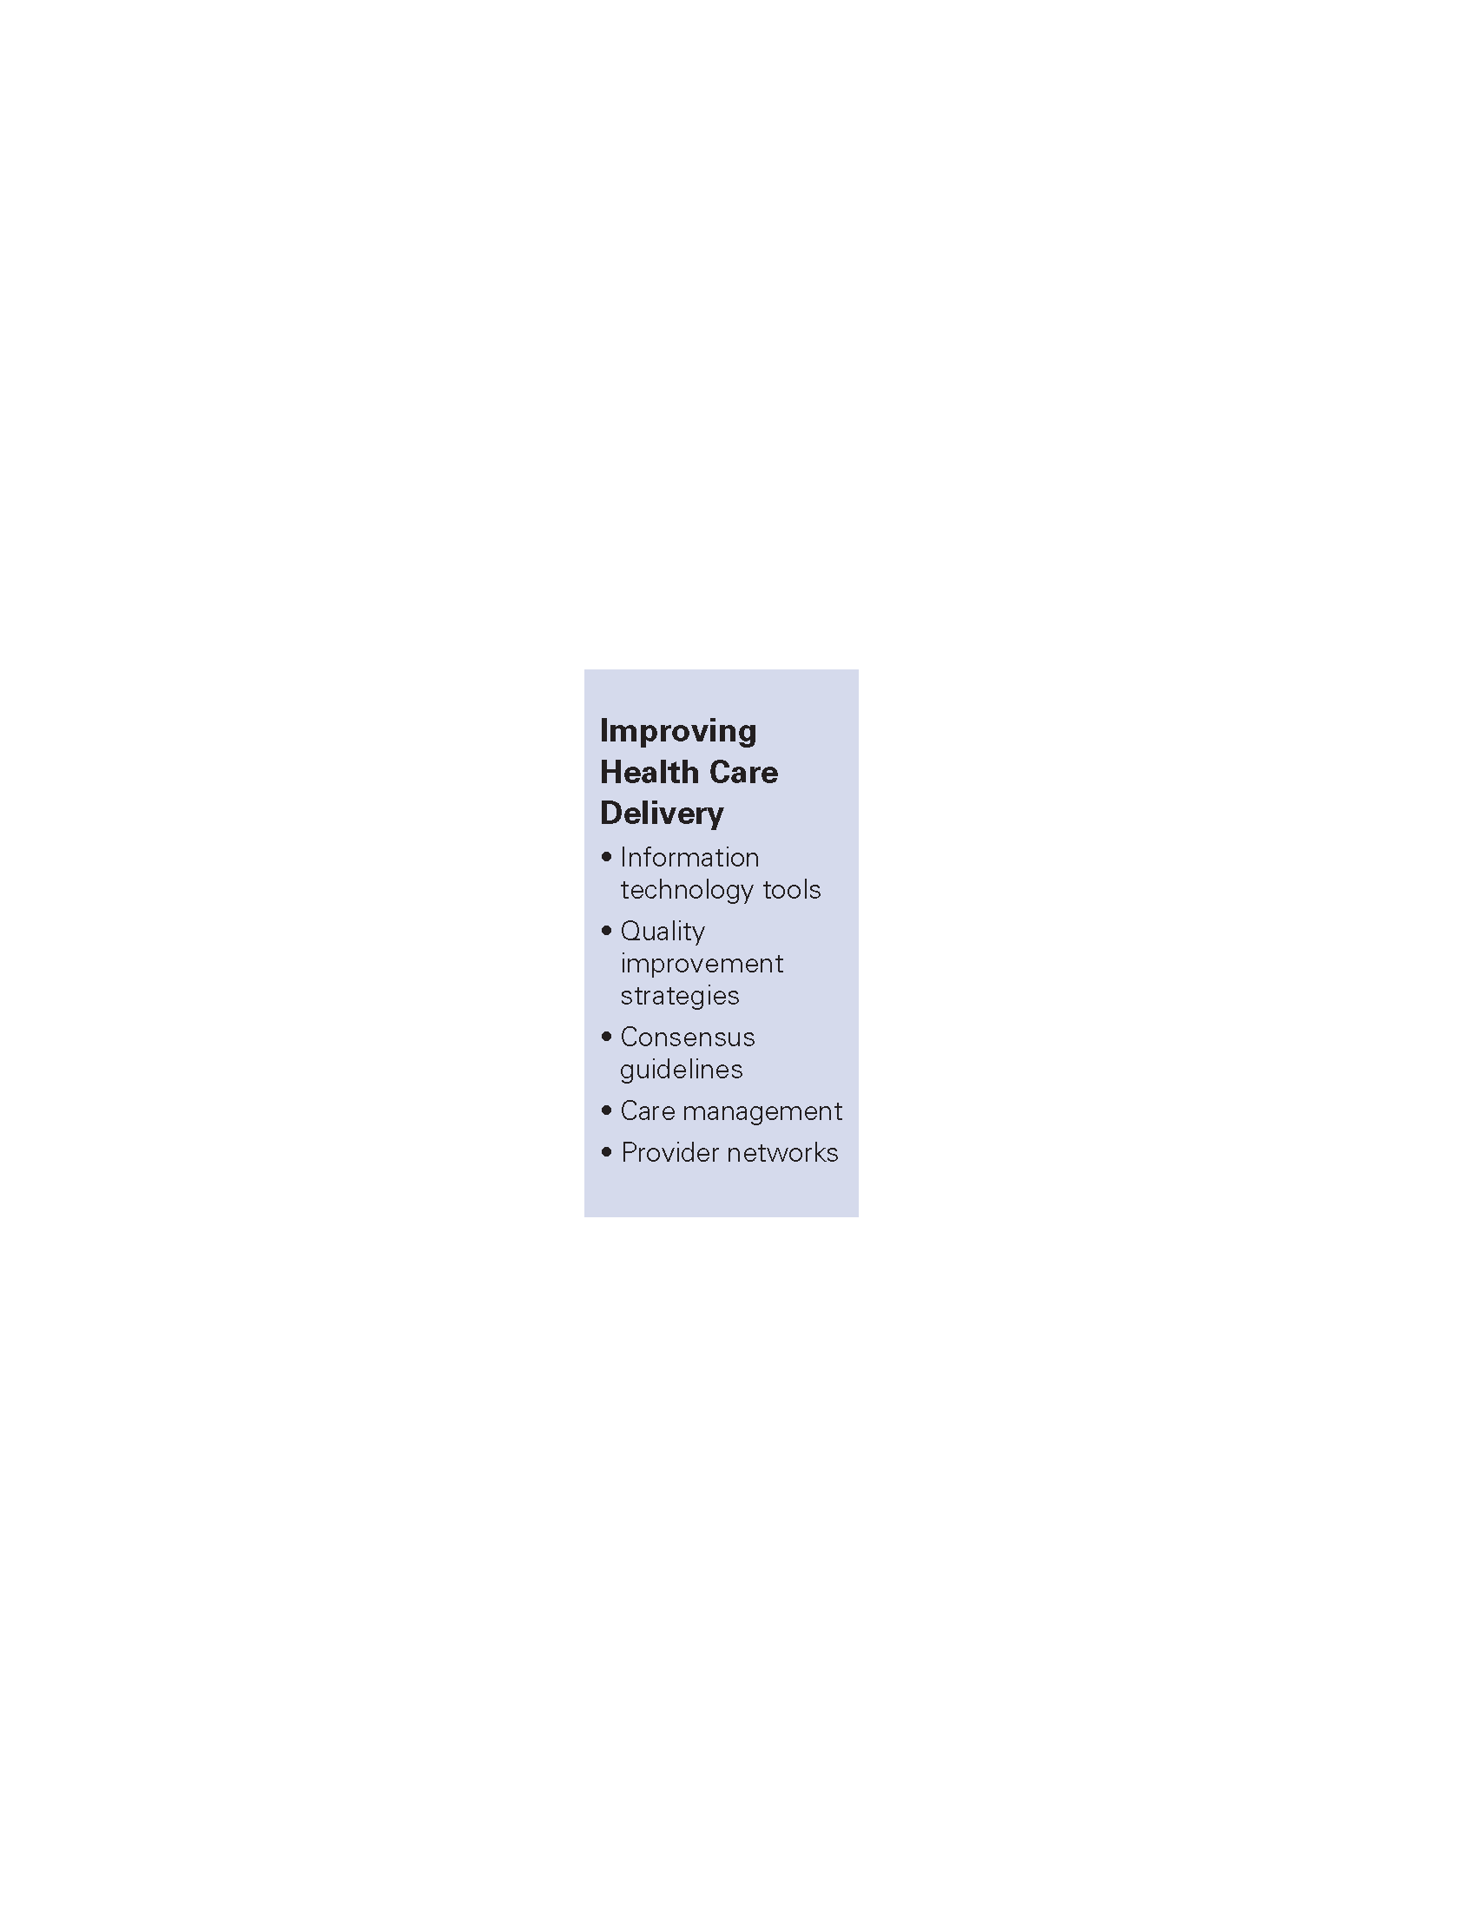


Leadership
The Framework might be best explained from the bottom up. The overall goals of the structure and activities described in the Framework are to:
- improve the quality of care and outcomes across a population, and
- reduce the costs of care for that population through waste reduction, outcome improvement, and greater administrative efficiency.

These ambitious goals are unlikely to be achieved without major redesign of our current care delivery systems, small and large. So, transformation or redesign of healthcare delivery in accord with the IOM Quality Chasm report’s aims is an important intermediate outcome. Such broad scale delivery system changes are unlikely without the three central strategies in the framework:

Engaging Consumers/Communities:
There are compelling arguments for greater consumer engagement in healthcare decisions, and many believe that more informed and actively engaged consumers, through their purchasing and care decisions, can induce healthcare systems to improve and become more efficient. To aid consumers, public disclosure of performance data is widely recommended, although there has been little demonstration of impact to date on consumer behavior. At the same time, purchasers are clearly shifting costs to consumers. While we lament the increased financial burden on consumers, cost-sharing strategies that lead to increased consumer involvement in care decisions may encourage more cost-effective care and reduce unwarranted, supply-driven demand.

Improving Healthcare Delivery:
Providers must have the clinical data systems, quality improvement strategies, and infrastructure to motivate and support the redesign of their delivery systems. Many small practices have neither the staff nor resources to mount such programs on their own, and some regional initiatives have provided assistance such as community–based case management services with positive effects. Finally, there are both national and international models of geographically-based physician networks to both spur diffusion of innovations in care and share resources.

Aligning Finance/Insurance:
Current reimbursement schemes provide multiple barriers to high quality, efficient care. Aligning benefits to promote cost effective and high quality care, and removing some of the disincentives, redundancies and inefficiencies in current health insurance and payment should reduce costs as well as encourage a transformation of care, especially if accompanied by financial incentives for improvement. Additionally, tackling the multiplicity of insurance claims forms, benefit packages, utilization management programs, etc. with a goal of administrative standardization and simplification has the potential of saving both consumers and providers considerable time and cost.

All three strategies benefit from the pooling of clinical and cost data to support clinical care and for performance measurement. The Framework reflects the fundamental role of pooled clinical data and performance measurement in creating a regional healthcare system with the capacity to improve. Providers would have feedback on their performance and the prospect of financial incentives. Purchasers and insurers would have access to complete data on their network providers to guide payment and quality improvement activities. Consumers would have information on the performance of various community providers.

The Framework identifies three key sets of stakeholders in transforming care—consumers, providers, and purchasers/health insurers. There needs to be an entity that convenes the three stakeholder groups, finds common ground, and provides leadership and direction. The literature on community health programming repeatedly gives emphasis to the importance of a shared vision and mission across the various stakeholder groups, and leadership that can make collaboration work.

Putting It All Together

The strategies described above are obviously linked. One can’t have any kind of successful program in regional healthcare without strong leadership and cooperation among those with the money and risk, those providing care and those receiving care. Performance measurement is essential for public disclosure and for performance-based reimbursement, as well as a crucial tool for practice improvement.

There is insufficient evidence at present to categorically state the essential features of an effective regional improvement program. Do you need activities in all areas or just a few? We believe that the four strategies—performance measurement, engaging consumers, supporting delivery system improvement, and aligning benefits and payment—are synergistic. If the IOM Quality Chasm report is correct, then effective regional programs would both change the financial and information technology environments to be more supportive of care improvement, AND help providers redesign their care systems to better meet the needs of patients.

___________________________
Note: The full report can be accessed at: https://www.chcf.org/publication/it-takes-a-region-creating-a-framework-to-improve-chronic-disease-care/

